- Bluebook Page60 November 2018 Variant One examination:

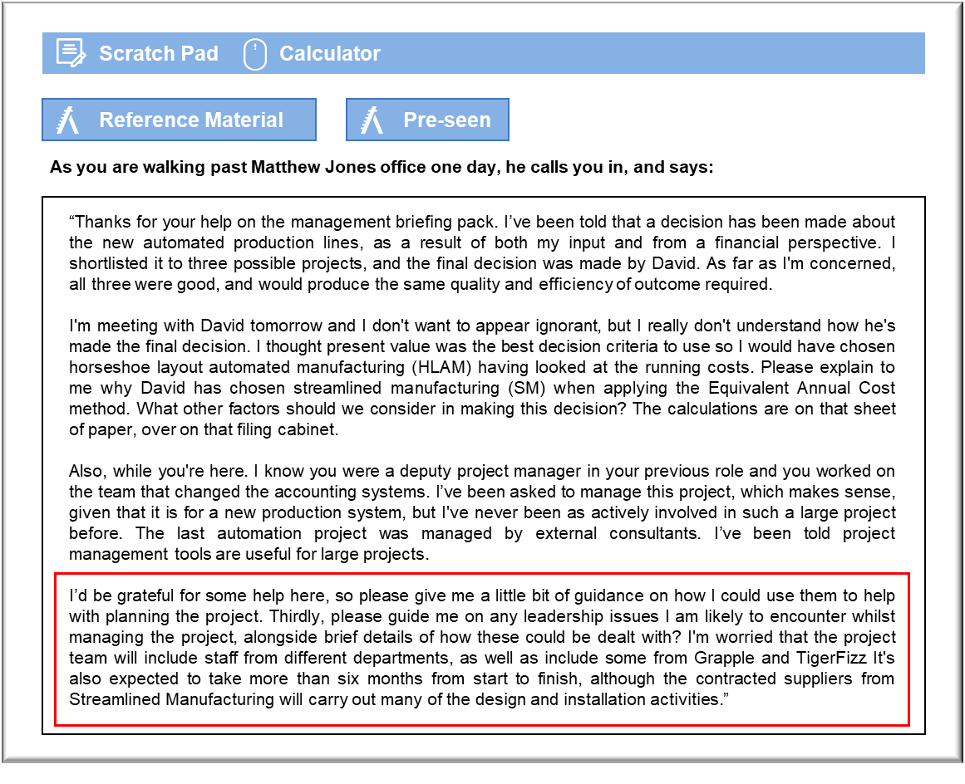

MANAGEMENT CASE STUDY NOVEMBER 2018 EXAM ANSWERS

Variant1 Task4
These answers have been provided by CIMA for information purposes only. The answers created are indicative of a response that could be given by a good candidate. They are not to be considered exhaustive, and other appropriate relevant responses would receive credit.

CIMA will not accept challenges to these answers on the basis of academic judgement.

Explanation of method for selecting from mutually exclusive projects
There are different ways that we can choose between mutually exclusive projects, but
the majority of them are based around the calculation of a present value i.e. what they
would cost in today's terms, given the time value of money.
When we have mutually exclusive projects which have different life expectancies, then
we must take this into account when deciding which to proceed with, given that those
with a shorter life expectancy will, presumably, need replacing sooner than an
alternative with a longer life. Hence, we cannot just compare a straightforward Net
Present Value (NPV).
David has used two methods here, although the first is very straightforward. In order to
reject the FFMS project, he has simply compared the required initial investment with the
amount of capital available for investment. In this case we have a capital ration of
Z$300,000 but the FFMS project would cost more than that initially. Therefore, it was
rejected. The rationing is soft in nature, which means we could be flexible with this, if it
was deemed worthwhile, however, we would need additional information in order to
decide this.
To decide between the HLAM and SM projects, David has used the method of
Equivalent Annual Cost. This approach determines the average annual cost in present
value terms, allowing projects to be compared despite the fact that they have different
useful lives (HLAM 20 years and SM 15 years). It assumes that the projects will be
continually replaced on a like for like basis in perpetuity.
All costs are determined, and the years in which they will be incurred. The present value
for each cost is then calculated by multiplying it by its present value factor, in this case
1/(1.10)n given the cost of capital of 10%. The present values of all costs are summed to
give a net present value (NPV) for the total costs. Whilst NPV calculations would
normally also contain benefits, it is considered that the benefits would be the same for
each (note 5) and hence these are not relevant to the ranking decision.
Once the NPV of costs is calculated, it is necessary to determine what the Equivalent
Annual Cost would be. This is calculated by dividing the NPV of costs by the Present
Value Annuity Factor for the lifetime of the investment. This provides us with the
average annual cost in present value terms.
As SM has a lower equivalent annual cost, it would be ranked higher than the HLAM
project and would be selected as the project to undertake, given your assurance that
they would be equally good in terms of efficiency and capacity.
November 2018 10 Management Case Study Exam
Other factors to be considered include technological advancements, cash flow, and
other uses for the available capital. In addition, you should not just look at the present
value of the running costs but the capital invested too.

The use of project tools in project management
There are many different tools available for project management. They are particularly
useful when the project involves a number of different activities and different personnel
involved, as appears to be the case here. Some of the key tools include:
Work Breakdown Structure – This breaks the project down into a selection of separate,
manageable activities. These can each be allocated durations and resources, (financial,
human and physical), allowing you to develop budgets (using a cost breakdown
structure), human resource plans and equipment requirements (using a product
breakdown structure). Statements of Work can also be produced to determine exactly
what needs to be done for each activity. This could be done by whoever you make
responsible for each particular activity.
Gantt charts and network diagrams - These are useful for planning when all of the
activities will take place, given the dependencies previously determined. This will allow
you to clearly see which activities are critical to ensure the project stay on track time?wise. For example, if the external suppliers cannot install the equipment until some
internal building work has been completed, you will know to keep an eye on this. The
Gantt chart has the added benefit of being able to track actual durations against
planned.
Resource Histogram – This allows you to determine when the different members of staff
will be required. I assume that they will not be full time on the project? This will allow
them to see when they will be working on the project. It also allows you to determine
whether there will be any staff shortages at any point in the project.
Scenario Planning – This can be used to see what the effect would be if you changed
the scheduling for some of the activities for example, or the availability of some of the
resources e.g. "what if the contractors were only available within these specified dates?"
Project Management Software, on the whole, contains all the necessary tools for
managing a project. Online software allows different personnel to access all relevant
information, and possibly update it, depending on their access rights.
There are also planning documents available to assist in planning a project, but the
above-mentioned are the key tools for doing so.
November 2018 11 Management Case Study Exam

Project management leadership issues
You are wise to be concerned about leadership issues, it is always a good idea to
consider them in advance so that you can come up with a plan for dealing with them.
One of the things you need to consider is the role of the different people within the
project team. Belbin suggests that people with different characteristics are needed in a
team, so you will need a team member who picks up on all the problems, for example,
but doesn't appear to offer solutions. It is important that you recognise the value of the
different team members as they all play their own role.
Tuckman suggests that teams need to go through a storming phase before they can
start to act as a 'normal' team. You should be prepared for this to happen, and to have
your conflict resolution skills well-honed for this! Much of this 'storming' may arise as a
result of the role or task allocation, especially if there is some existing rivalry between
departments or between the original Grapple staff and those coming from TigerFizz.
You may need to act as a negotiator on a number of occasions.
You should take into consideration that this project will lead to redundancies. You may
need some sensitivity. It's possible that some members of the project team will be losing
their jobs if the project is successful. Therefore, the actual selection of team members
will be one of the first leadership issues faced. Should you select only those retaining
their roles, especially as this will give them greater insight into the new processes?
You will encounter leadership challenges along the way, as very few projects run to time
or budget. You may have to make some tough decisions, which are not appreciated by
the team members. For example, if one activity is critical, there may be a requirement
for the use of overtime to complete it on time. Allowing team members to participate in
the decision-making processes would allow them to take partial ownership of these
tough decisions and be more likely to accept them without resistance.
Remember that leadership is about motivation. You already know how to lead a team in
your role here in Grapple, you should simply adapt those skills to a multi-functional
project team. Communication about what is happening, when, how and who is
expected to be involved can prevent many leadership issues from arising in the first
place.

